Some brief notes on the testing of the LED dampers for the ILEE-EERF tests:
All four devices were tested under fully reversed sine wave testing. The devices were first moved so that the bulged shaft was positioned to provide the ability to undergo equal positive and negative displacements. As a result, the zero displacement position does not match that when the devices are positioned within the shake table test. Within the shake table test, the positive and negative displacement demands are different (much larger extension demand than compression demand).
Furthermore, when the LEDs were mounted into the MTS dynamic test machine, they utilized end conditions which provide flat metal surfaces to be gripped within hydraulic wedge grips. This does not match the pinned-pinned end conditions using spherical bearings which will be used during final testing. The pinned-pinned end conditions were also tested in an Instron test machine, to almost exactly replicate the in-service device conditions. However, this Instron test machine was only capable of quasi-static testing and could not provide dynamic testing capability. The MTS testing is intended to provide insight into the force behavior when subjected to dynamic testing, whereas the Instron testing represents testing using the exact installed conditions of the dampers.
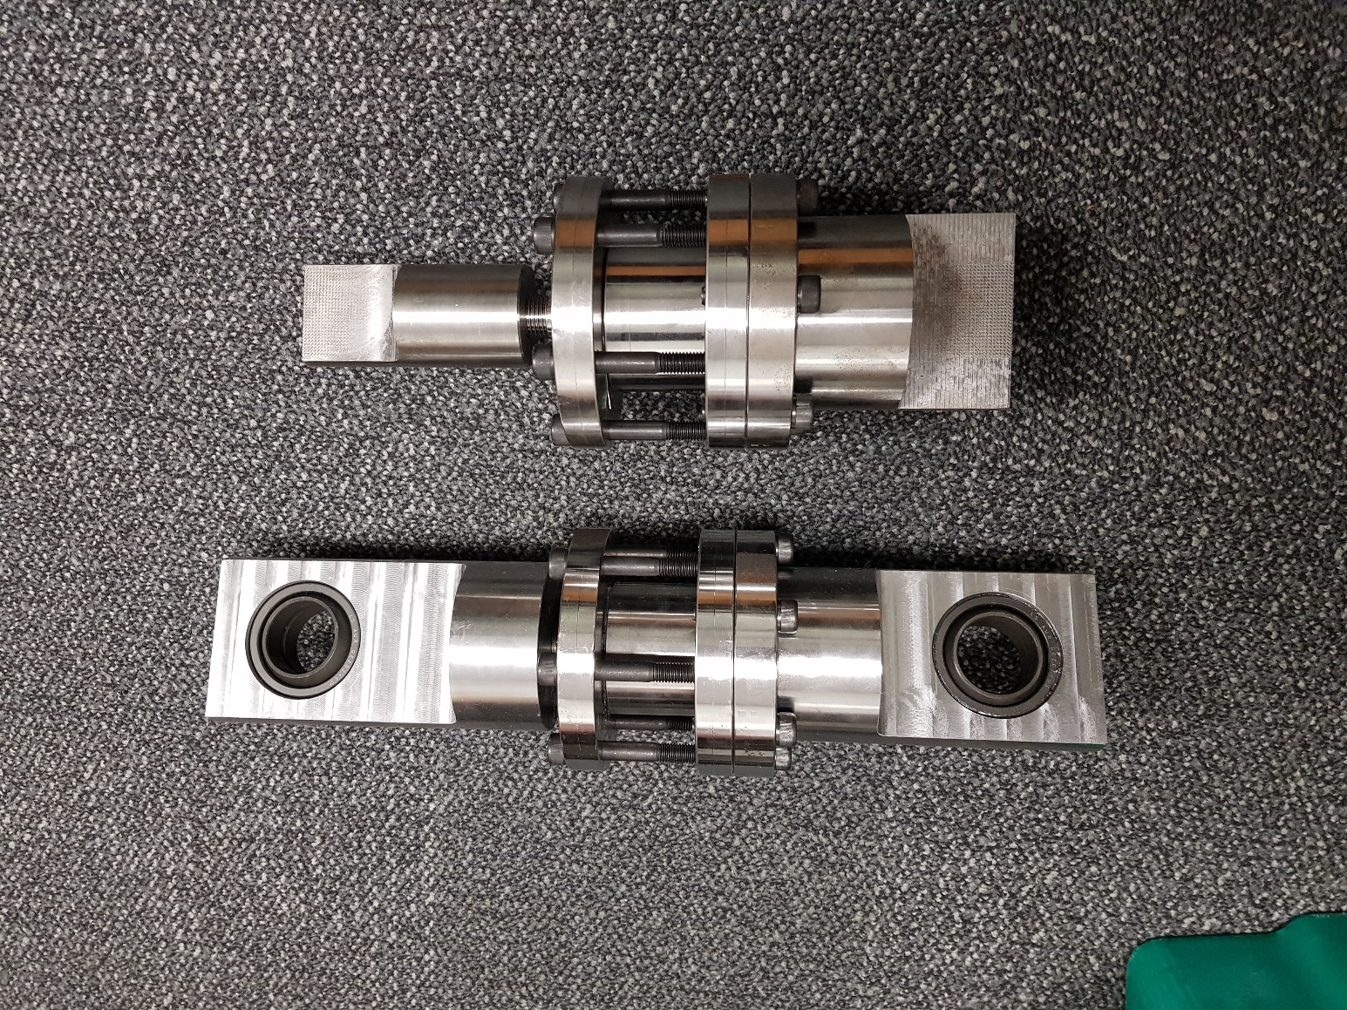 | 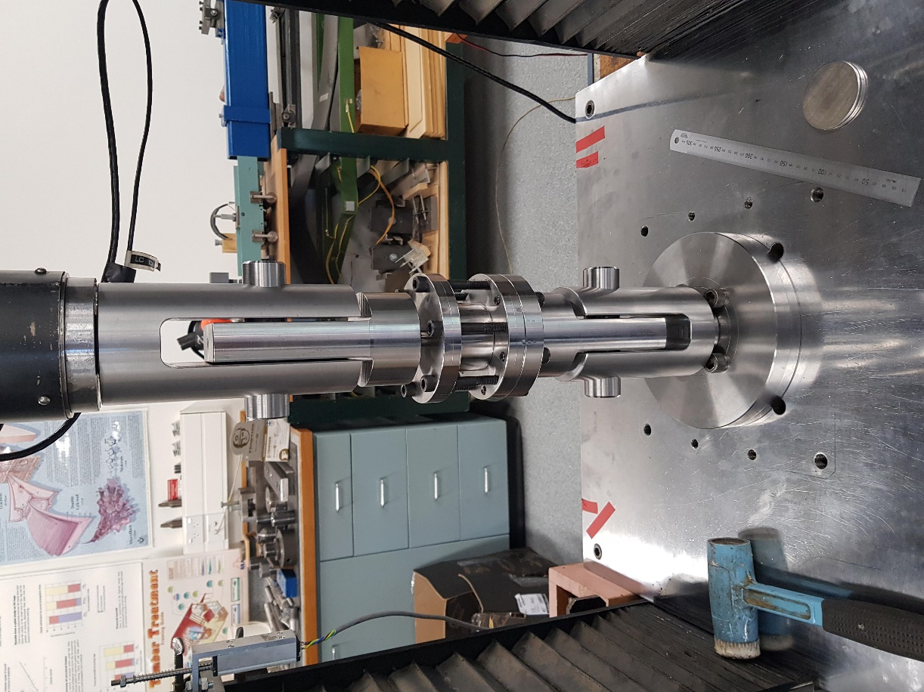
- LEDs asssmbled with mounts. Left: mounts using spherical bearings exactly as in the test structure. Right: Mounts with flat surfaces for MTS hydraulic wedge grips. | - LED mounted within the Instron test machine using the mounts with spherical bearings.
Figure 1: LED damper showing their set-up for dynamic testing and quasi-static testing.
- Device 1 | - Device 2
- Device 3 | - Device 4
Figure 2: Individual LED test results. Each device is tested with a fully-reversed sine-wave input displacement with 10mm amplitude, at frequencies of 0.01Hz, 0.1Hz, and 0.2Hz.

- Overlay of all four devices tested at 0.01Hz
- Overlay of all four devices tested at 0.1Hz
- Overlay of all four devices tested at 0.2Hz
Figure 3: LED test results – results of all four devices, grouped by testing frequency.

